**HOLIDAYS IN STAVROS - CHALKIDIKI**

[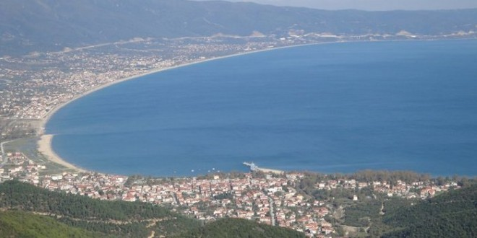](http://www.google.gr/url?sa=i&rct=j&q=&esrc=s&source=images&cd=&cad=rja&uact=8&ved=0ahUKEwj514zu_YnSAhXLaxQKHYUSBlgQjRwIBw&url=http%3A%2F%2Fwww.dhmos.gr%2Fdimos-bolbis%2F&psig=AFQjCNFDg8ZBQKmCYN-30dWMZ2iZ8G9mcQ&ust=1486967905080354)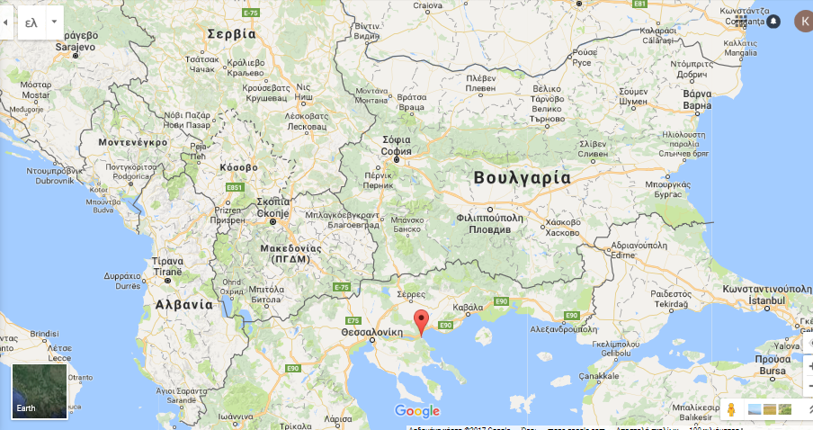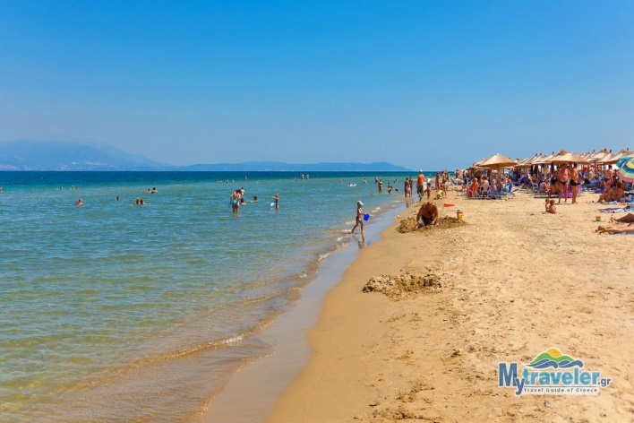[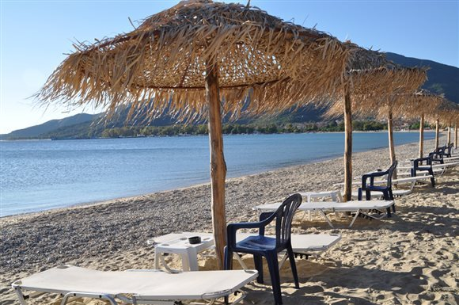](http://www.google.gr/url?sa=i&rct=j&q=&esrc=s&source=images&cd=&cad=rja&uact=8&ved=0ahUKEwjMr53V_YnSAhXFbRQKHQWrBVgQjRwIBw&url=http%3A%2F%2Fwww.deltiokairou.gr%2Fgr%2Flifestyle%2Farticle%2F64%2F10-paralies-tis-thessalonikis-poy-prepei-na-boytixeis%2F&psig=AFQjCNFDg8ZBQKmCYN-30dWMZ2iZ8G9mcQ&ust=1486967905080354)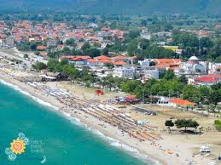[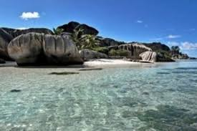](https://www.google.gr/imgres?imgurl=http%3A%2F%2F1.bp.blogspot.com%2F-oTcGfyeO2Ww%2FUgOpsehXlPI%2FAAAAAAAGHGg%2FoDEnJ_QkEb8%2Fs400%2F1.JPG&imgrefurl=http%3A%2F%2F365diakopes.blogspot.com%2F2013%2F08%2Fblog-post_8.html&docid=YWS4kWhU_qVOBM&tbnid=C7OfMxm5w5hPoM%3A&vet=1&w=400&h=266&bih=676&biw=1578&q=%CF%83%CF%84%CE%B1%CF%85%CF%81%CE%BF%CF%82%20%CE%B8%CE%B5%CF%83%CF%83%CE%B1%CE%BB%CE%BF%CE%BD%CE%B9%CE%BA%CE%B7%CF%82%20%CF%87%CE%B1%CF%81%CF%84%CE%B7%CF%82&ved=0ahUKEwic5L-slYrSAhXLuxQKHZM4A1gQMwh5KFIwUg&iact=mrc&uact=8)[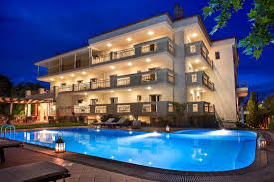](https://www.google.gr/imgres?imgurl=https%3A%2F%2Fmedia-cdn.tripadvisor.com%2Fmedia%2Fphoto-s%2F09%2F4c%2F98%2Ff7%2Felectra-hotel.jpg&imgrefurl=https%3A%2F%2Fwww.tripadvisor.com.gr%2FTourism-g2292053-Stavros_Thessaloniki_Region_Central_Macedonia-Vacations.html&docid=lJivxkbZluHqZM&tbnid=yePKNZ9J__FibM%3A&vet=1&w=550&h=367&itg=1&bih=676&biw=1578&q=%CF%83%CF%84%CE%B1%CF%85%CF%81%CE%BF%CF%82%20%CE%B8%CE%B5%CF%83%CF%83%CE%B1%CE%BB%CE%BF%CE%BD%CE%B9%CE%BA%CE%B7%CF%82%20%CF%87%CE%B1%CF%81%CF%84%CE%B7%CF%82&ved=0ahUKEwic5L-slYrSAhXLuxQKHZM4A1gQMwhaKDMwMw&iact=mrc&uact=8) 